Teacher Eliane Cavalher S. Rossi – elianecavalher@gmail.com

ACTIVITY 9 – ELEM II –

BUYING CLOTES – LISTENING

**Listen to a man shopping for clothes. Correct the wrong sentences. Tick the right ones.**



**Example:**

-. The woman doesn’t buy anything. She is just looking: _______

-. The man wants to buy ~~jeans.~~  **_trousers__**

1. He wants them in blue colour: **__________**

2. He thinks he is size 34: **__________**

3. He tries them on in the changing room but they´re a bit too large: **__________**

4. The shop assistant gives him size 32: **__________**

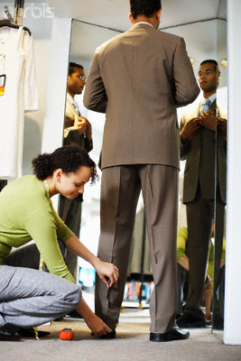

5. The shop assistant says they look very nice: __________

6. The man thinks they’re too small: **__________**

7. The shop assistant says that’s the fashion now: __________

8. He takes them and asks to pay by credit card:  **__________**

ACTIVITY 9 – ELEM II

BUYING CLOTES – LISTENING - KEY

**Listen to a man shopping for clothes. Correct the wrong sentences. Tick the right ones.**

**Example:**

-. The woman doesn’t buy anything. She is just looking: _____

-. The man wants to buy ~~jeans.~~  **_trousers _**

1. He wants them in blue colour: **__brown __**

2. He thinks he is size 34: **___ 32____**

3. He tries them on in the changing room but they´re a bit too large: **__small___**

4. The shop assistant gives him size 32: **___34____**



5. The shop assistant says they look very nice: ______

6. The man thinks they’re too small: **____big___**

7. The shop assistant says that’s the fashion now: ______

8. He takes them and asks to pay by credit card:  **__cheque_**